[paste your model in place of the example below]
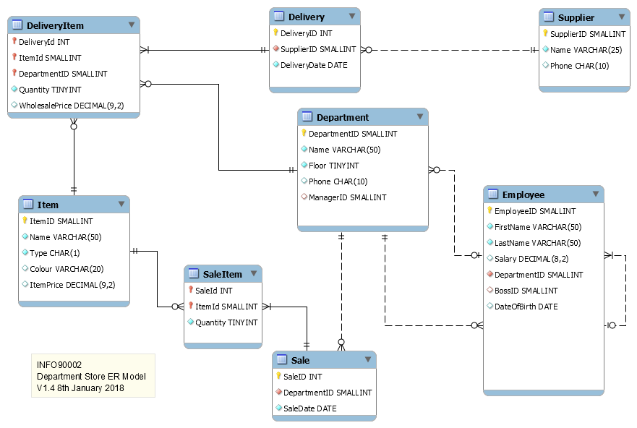

Data Dictionary

[details here]

Work Breakdown

[details here]

